Appendix 4 Checklist for annual review of the anti-bullying policy and its implementation
The Board of Management (the Board) must undertake an annual review of the school’s anti-bullying policy and its implementation. The following checklist must be used for this purpose. The checklist is an aid to conducting this review and is not intended as an exhaustive list. In order to complete the checklist, an examination and review involving both quantitative and qualitative analysis, as appropriate across the various elements of the implementation of the school’s anti-bullying policy will be required.
Has the Board formally adopted an anti-bullying policy that fully complies with the requirements of the Anti-Bullying Procedures for Primary and Post-Primary Schools? | Y
Has the Board published the policy on the school website and provided a copy to the parents’ association? | Y  Available on request
Has the Board ensured that the policy has been made available to school staff (including new staff)? | Y
Is the Board satisfied that school staff are sufficiently familiar with the policy and procedures to enable them to effectively and consistently apply the policy and procedures in their day to day work? | Y
Has the Board ensured that the policy has been adequately communicated to all pupils? | Y  At assemblies
Has the policy documented the prevention and education strategies that the school applies? | Y
Have all of the prevention and education strategies been implemented? | Y
Has the effectiveness of the prevention and education strategies that have been implemented been examined? | N
Is the Board satisfied that all teachers are recording and dealing with incidents in accordance with the policy? | Y
Has the Board received and minuted the periodic summary reports of the Principal? | Y
Has the Board discussed how well the school is handling all reports of bullying including those addressed at an early stage and not therefore included in the Principal’s periodic report to the Board? | Y
Has the Board received any complaints from parents regarding the school’s handling of bullying incidents? | N
Have any parents withdrawn their child from the school citing dissatisfaction with the school’s handling of a bullying situation? | N
Have any Ombudsman for Children investigations into the school’s handling of a bullying case been initiated or completed? | N
Has the data available from cases reported to the Principal (by the bullying recording template) been analysed to identify any issues, trends or patterns in bullying behaviour? | N
Has the Board identified any aspects of the school’s policy and/or its implementation that require further improvement? | Y
Has the Board put in place an action plan to address any areas for improvement? | New Bí Cineálta coming in next year give an opportunity to totally review the policy

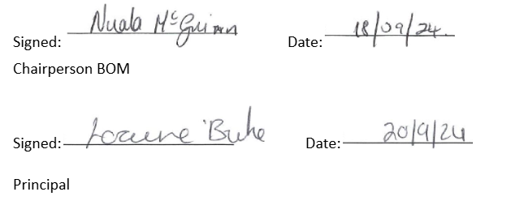

Notification regarding the Board of Management’s annual review of the anti-bullying policy

To: Trinity P.S. Schppl Community

The Board of Management of Trinity P.S. wishes to inform you that:

  - The Board of Management’s annual review of the school’s anti-bullying policy and its implementation was completed at the Board meeting of 200/9/24

  - This review was conducted in accordance with the checklist set out in Appendix 4 of the Department’s Anti-Bullying Procedures for Primary and Post-Primary Schools.

